#include <iostream>

#include <stdio.h>

#include <stdlib.h>

using namespace std;

struct simpul {

string nama,keluhan,tanggal;

int umur;

simpul \*next;

};

simpul \*node, \*head = NULL, \*tail = NULL;

//Fungsi Cetak

void tampil (){

cout <<endl;

cout << "\t======================="<<endl;

cout << "\tPrint Data"<<endl;

cout << "\tNama \t: "<< node->nama<<endl;

cout << "\tkeluhan \t: "<< node->keluhan<<endl;

cout << "\tumur \t\t: "<< node->umur<<endl;

cout << "\ttanggal \t\t: "<< node->tanggal<<endl;

cout << "\t======================="<<endl;

cout <<endl;

}

main () {

bool exit = false;

int chooseMenu;

do{

ulang:

printf("\t==== KLINIK RUMAH SAKIT =====");

printf("\n\t1. Masukan Data \t");

printf("\n\t2. Lihat Data \t");

printf("\n\t3. Exit \t\n ");

printf("\t============================\n");

printf("\n\t Masukan Pilihan : " ); cin >> chooseMenu;

printf("\t============================\n");

switch(chooseMenu){

case 1 :

node = new simpul;

cout <<endl;

cout << "\tNama \t: "; cin >> node->nama;

cout << "\tkeluhan \t: "; cin >> node->keluhan;

cout << "\tumur \t\t: "; cin >> node->umur;

cout << "\ttanggal \t\t: "; cin >> node->tanggal;

cout <<endl;

if(head == NULL){

head = node;

tail = node;

}else{

node->next = head;

head = node;

}

system("cls");

goto ulang;

break;

case 2 :

node = head;

printf("\n\t====DATA Di CETAK====\n");

while (node != NULL){

tampil ();

node = node->next;

}

if(node == NULL){

printf("\n\t DATA Selajutnya KOSONG \n");

}

break;

case 3 :

exit = true;

break;

}

}while(exit == false);

}

Input

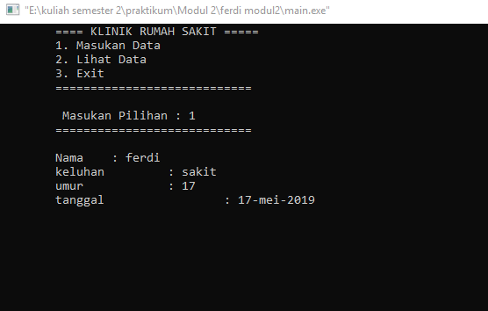

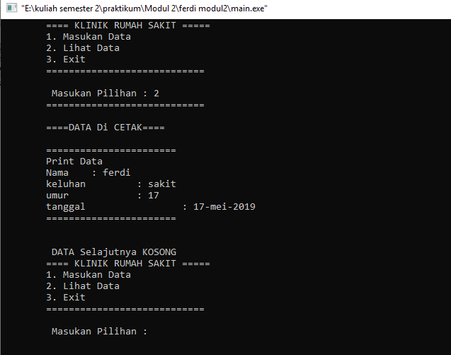Output